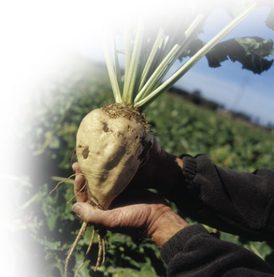
Sugar beet fibre – just right for you!
Consumers are very much aware of the health benefits of higher fibre intake; often unknown is that different fibres have various advantages.
VIDOFIBRES BF - sugar beet fibre - produced from sugar beets after the sugar extraction, has a low remaining sugar content (< 5%). The fibre is a mix of insoluble and soluble fibre, the insoluble part is mainly hemicellulose, and the soluble component is pectin. Several clinical studies with sugar beet fibre describe its advantages for the human body. On top of this, it has functional properties, e.g. to prolong freshness in bread and reduce frying losses in minced meat due to thermo-stable water holding. VIDOFIBRES BF sugar beet fibre is free from gluten and works well in gluten-free bread and cakes. Also, it is free from phytic acid, which could act as a mineral blocker.
Digestive health

Sugar beet fibre is extensively documented because it was used as the fibre of choice in many studies, both nutritional and functional*. Clinical studies confirm that several gastro-intestinal problems can be helped by consuming Sugar beet fibre**. It counteracts constipation and promotes regularity. According to some studies, it can prevent inflammatory conditions since the insoluble fibre/pectin flushes out waste products collected in pockets inside the gut system. The waste matter in the colon could contain toxins, and the longer it stays in the intestines, the higher the risk of developing dangerous diseases.
The soluble fibre part increases short-chain fatty acid (SCFA) production. SCFAs are essential for a healthy environment in the gut system, e.g. they have been shown to protect the colon mucosa.

Weight management
Because of its water-absorbing capabilities, VIDOFIBRES BF sugar beet fibre functions as filler, gastric emptying is slowed down, and the feeling of satiety is prolonged. Noteworthy is the pectin fermentation in the gut system and increased concentration of organic acids, mainly acetate, which can reduce the appetite, according to a study made by the Imperial College in London.

Health claims
VIDOFIBRES BF sugar beet fibre allows an EU health claim on increased fecal bulk ***. The homogeneous network of polysaccharides with its high microporosity and water retention capacity results in a high fermentability by human gut bacteria, increasing the wet and dry fecal output. Pectin, the soluble part in this fibre, has two EU health claims: normalizing the bad LDL cholesterol and stabilizing the blood sugar after a meal.

“Many large bowel disorders may be attributed to lack of fecal bulk (Kritchevsky 2001)”.
* Handbook of Dietary Fibre 2001.
**Lampe et al 1993, Castiglia et al 1998, Giacosa et al 1990.
*** EU 13.5 claim “SBF contributes to increased fecal bulk.”

